Introduction to our founder, Mike Florance.
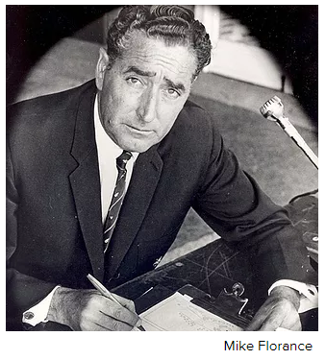
Our founder Mike Florance had the foresight to establish a club with no fixed abode where like-minded golfers could get together once a month to enjoy each other’s company and at the same time raise money for those less fortunate than us and for the furtherance of golf.
His philosophy and in his words, "There is room in this game for some kind of Association or Club for business and professional men to come together in a closely planned and integrated programme of golf, with all games interrelated and offering a continuing thread of interest and that out of this activity could arise some tangible benefit to two very proper causes: to the game of golf itself, and to those less fortunate than ourselves."
In 1960 the Transvaal Nomads Club (now Gauteng Nomads) was established followed shortly by Natal in 1963 and Western Province in 1965. From there the concept spread like wildfire throughout the country and today the club comprises twelve clubs in South Africa, three in Zimbabwe, one each in Botswana, Swaziland, New Zealand, Zambia and the UK and five clubs in Australia.
NUMICS – ‘Follow the Sun’ – Nomads
The Nomads Club, as it is today, came about as a transition from NUMICS via ‘Follow the Sun’ through to the development of Nomads. Shortly after World War II, a consortium of companies called the New Union Merchant Industrial Corporation (NUMIC) was formed in Johannesburg, with a certain Michael Florance as personnel officer. Because of the diversity of the various subsidiary companies, Mike Florance was authorised to implement his proposal that a NUMIC Social & Sporting Club be formed to enable staff members to get to know each other.
Being a keen golfer, Mike became the honorary organiser of the NUMIC Golf Club. Not having a course of their own, the members had to obtain the courtesy of the courses on which they played, but in those days Saturday mornings were a slack time for local golf clubs and it was a pleasure for them to host an organised, thirsty group of golfers. Membership of NUMICS was soon extended to business associates and friends and the meetings became even more enjoyable.
In 1960, soon after the life story of American golfing legend, Ben Hogan, was portrayed in the movie, Follow the Sun, Mike Florance and his committee announced the formation of the ‘Follow the Sun’ Nomads Golf Club under the aegis of the National War Memorial Health Foundation. The lapel badge was similar to the Nomads badge we have now hanging from the name bar, but it consisted of a bell alone with a scroll on the top edge, with the legends Follow the Sun and Onthou 1939–1945 immediately above the bell. The background colours were yellow (sun) in the upper half and green (grass) in the lower half. The choice of the bell was prompted by a line from the Meditations of John Donne – For Whom the Bell Tolls – symbolising remembrance of those who had lost their lives in World War II. This is now our creed.

